CAN DO HOME SERVICES
PROFESSIONAL HOME INSPECTION

March 6, 2012

Visual Property Inspection
701 5th Ave
New Hyde Park, NY 11040

Prepared for:
Bill Hees
13 Cross St., Belmont, Ma 02478
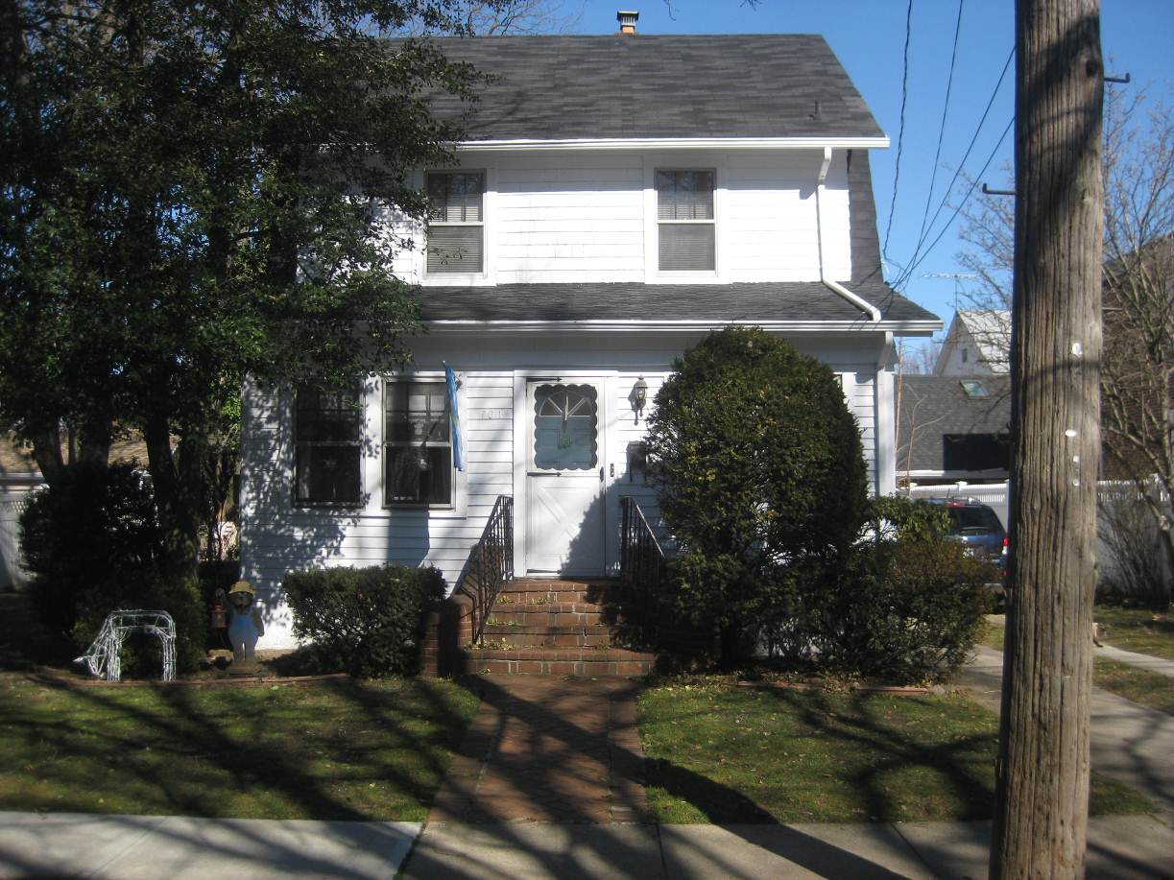

Inspected by :
BOB VAN STRY
Lic.# 1600005960

34 Metzner Rd.,
Ronkonkoma, New York 11779
Phone : (631) 467-8900
e-mail : candohomeinsp@aol.com

PROPERTY AND SITE
701 5th Ave., New Hyde Park, NY 11040 03/06/12 10:00 AM
____________________________________________________________________________________________________
LIMITATION: Restricted / No Access Debris / Obstruction Snow / Ice Cover Vegetation/Tree/Shrub
CONDITIONS: Clear / Sunny Cloudy / Overcast Rain / Snow Approx. Temperature
Wet / Swampy / Damp / Dry / Frozen Ground Approx. Hydrant Distance
_________________________________________________________________________________________________________________
BUILDING Approx. 90 Years Old
Traditional Cape Cod Colonial Hi-Ranch Dutch Colonial Ranch Bungalow Victorian
Rural Bi-Level Tri-Level Addition Condo Row / Town Other 2 Story 3 Story

Items like in-ground sprinkler system, above ground pool and components, hot tub and deck wet bar were not checked nor inspected as per our agreement.
Visible evidence indicates an acceptable level of construction.
No movement is evident.
Inspection of the structural components was restricted due interior finishes.

_________________________________________________________________________________________________________________
LANDSCAPING Slopes to House FUNCTIONAL
Ravine Site Erosion Flower Bed Hedge / Shrub Tree / Vine Earth to Wood No Swale Other
_________________________________________________________________________________________________________________
DRIVEWAY Slopes to House DAMAGED—YES
Paving Stone Gravel Concrete Asphalt Dirt Parking Area None
Repair to the concrete will be needed.
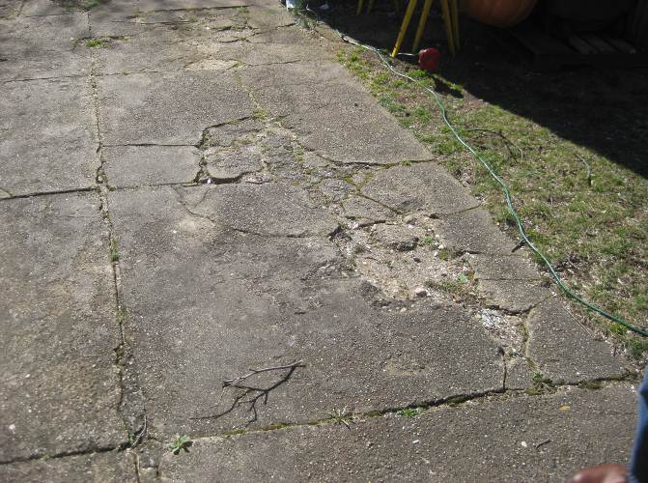
_________________________________________________________________________________________________________________
WALKWAY/PATH Slopes to House DAMAGED—NO
Paving Stone Gravel Concrete Asphalt Brick Slate Dirt Other
_________________________________________________________________________________________________________________

PORCH Unsecured DAMAGED—NO
Metal Wood Concrete Brick Block Slate
Spalling Crack Corrosion Rot Settlement Repaint / Stain Weather Seal Caulk
Enclosed front porch.
Front steps looked ok. Some repointing will be needed.
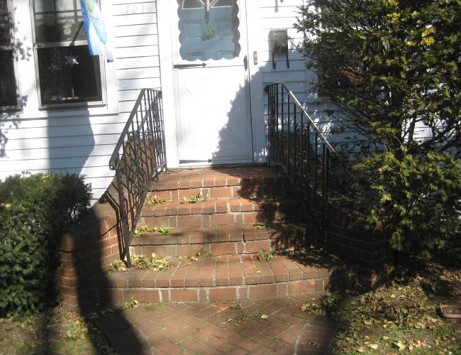
_________________________________________________________________________________________________________________
LIGHTING OPERATIONAL—YES
None Unsecured Not Tested
___________________________________________________________________________________________________
RECEPTACLE OPERATIONAL—YES
No Cover Damaged GFCI
_________________________________________________________________________________________________________________
RAILING Unsecured FUNCTIONAL
Metal Wood PVC Incomplete None
Metal handrail is getting loose.
_________________________________________________________________________________________________________________
DECK / PATIO Unsecured Slopes to House N/A
Composite Wood Brick Block Concrete Metal Trex Slate
Paving Stone Patio Block Stone
Crack Settlement Spalling Deterioration Mold Mildew Rot
__________________________________________________________________________________________________
RETAINING WALL Not Stable N/A
No Weep Holes Wood Concrete Stone Brick
Crack Spalling Deterioration Rot Leans

EXTERIOR

701 5th Ave., New Hyde Park, NY 11040 03/06/12 10:00 AM
______________________________________________________________________________________________________________
LIMITATION: Clearance Seasonal Storm Windows Debris / Obstruction Shrub / Tree / Hedge / Vines / Ivy
Snow / Ice Cover Restricted / No Access Parged Other
______________________________________________________________________________________________________________

FOUNDATION WALL Not Exposed Limited Exposure FUNCTIONAL
Poured Concrete Block Brick Stone
Exterior Rigid Insulation PWF / Wood Piling / Pier Cracking / Spalling Mildew / Mold
Stain / Rot Frost Heave
Parging on foundation wall conceals condition of walls. Some cracks were seen. Front corner will need repair where wood is coming off the concrete block corner.
Regrading away from foundation is needed in some areas to help keep water away. Fill and seal foundation cracks to reduce potential water penetration and subsequent damages.
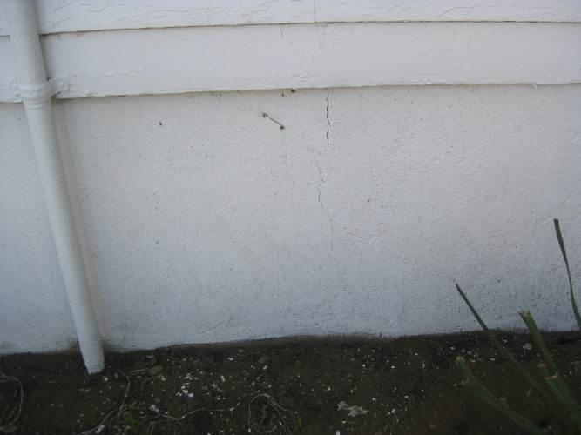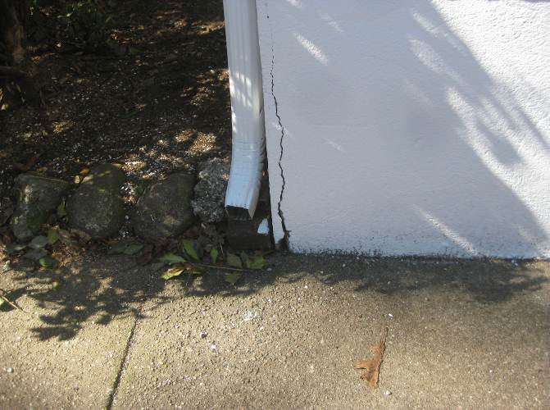
_______________________________________________________________________________________________________________
WALL SURFACE No Ground Clearance DAMAGED—NO
Aluminum Composite / Concrete Brick / Block Stone Stucco Vinyl Siding Wood Siding
Steel / Shingle Split / Loose Repoint Repaint Recaulk
Crack / Spalling Mildew / Mold Stain / Rot Blister / Peel
Wood Siding is old . Some areas are worn more than others. Siding repair or replacement will be needed soon.
_______________________________________________________________________________________________________________
Windows Inspected with Binoculars DAMAGED—NO
Storm Unsecured Repaint Recaulk Weather-strip Mildew / Mold Stain / Rot Poor Trim
Old wood windows. Some panes were cracked. Some rot to trim was seen. Basement windows were in poor condition and need replacing.
________________________________________________________________________________________________________________

WINDOW WELL Improper Drainage Well Covers Clean N/A
Should have window wells along the side of the driveway. To help keep water away from the foundation.
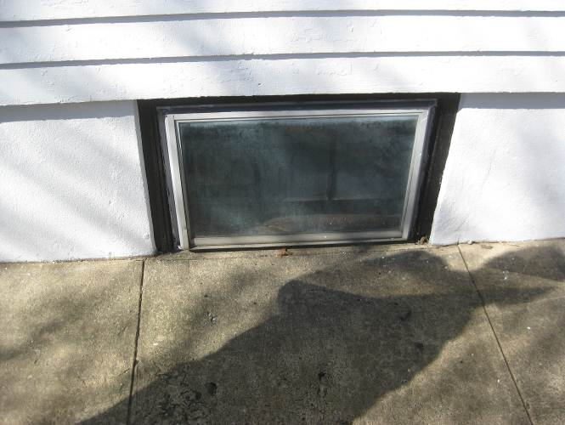 ________________________________________________________________________________________________________________
DOORS Binds Damaged DAMAGED—NO
Storm Unsecured Repaint Recaulk Weather-strip Mildew / Mold Stain / Rot Split / Dent
Exterior doors were old and getting in poor condition. They need better weatherproofing and adjustment.
__________________________________________________________________________________________
LIGHTING OPERATIONAL—YES
None Unsecured Not Tested
____________________________________________________________________________________________________

ROOF STRUCTURE

701 5th Ave., New Hyde Park, NY 11040 03/06/12 10:00 AM
_______________________________________________________________________________________________________________
INSPECTED BY: Binocular Roof Edge Walk On No Access

LIMITATION Deck / Patio Gravel / Flat Height Steep Slope Rain / Snow / Ice Cover
Solar Panel Fragile Other
Because of height and steep slope I could not walk on this roof.
________________________________________________________________________________________________________________
MAIN ROOF Flat Gable Valley Hip Shed Other Poor Pitch Est. Age
________________________________________________________________________________________________________________
GUTTER / DOWNSPOUT Unsecured FUNCTIONAL

TYPE Aluminum Galvanized Copper Plastic
Incomplete Dent / Split Corrosion Leak Gutter Covers
DRAINAGE Above Ground Below Ground Spill / Roof Extend Leader Redirect Leader Clean

Clean and maintain gutter system regularly to reduce chance of water damages as a result of clogging. Extend all downspouts minimum 6' away from foundation to reduce wall deterioration, potential water entry and subsequent damages.
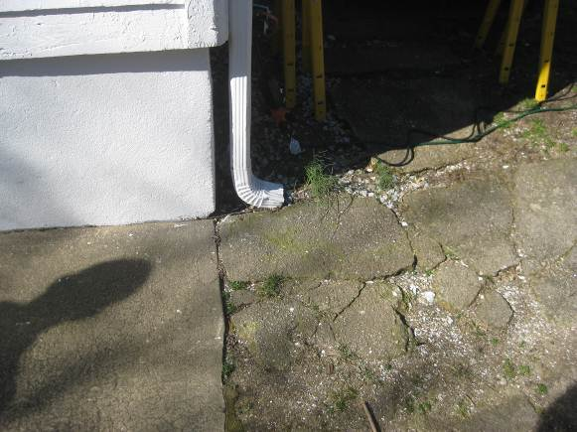
________________________________________________________________________________________________________________
FASCIA / SOFFIT Not Vented DAMAGED—NO
Aluminum Wood Vinyl Other Loose Mildew / Mold Stain / Rot Corrosion
_______________________________________________________________________________________________________________
COVERING NUMBER OF LAYERS 1 DAMAGED—NO
Asphalt Shingle Fiberglass Shingle Concrete / Clay Tile Wood Shingle Wood Shake Tar / Gravel Metal
Nail Exposed / Pop Loose / Missing Broken Crack Patched Mildew / Mold Fungus / Moss Worn
Curl / Claw Stain / Rot Improper Installation
LIFE EXPECTANCY Typical Middle End Exceeded

Shingles are functioning as intended.
Monitor seasonally for loose shingles, wind damage and deterioration.
________________________________________________________________________________________________________________
ACCESSORY Unsecured DAMAGED—NO
Air Vent Exhaust Vent Vent Stack Turbine Electric Mast Solar Panel Skylight Dish Antenna
________________________________________________________________________________________________________________
FLASHING Not Checked / Concealed DAMAGED—NO
Chimney Dormer Drip Edge Flat Roof Skylight Roof to Wall Stack Valley Roll Roofing
Aluminum Galvanized Copper / Lead Rubber
Gap Loose Crack Deterioration Corrosion Tarred Patched
Reseal Recaulk Improper Replace When Re-Roofing
________________________________________________________________________________________________________________
CHIMNEY / VENT Leaning DAMAGED—NO
Fireplace Furnace Gas Insert Other
Brick Block Stone Metal Wood Stucco Chase
Crack Spalling Deterioration Corrosion Loose Abandoned No Wind Cap Metal Liner Required
Repointing and repair to the cracks is needed at base of chimney by the boiler. Have a mason give estimate to repair.
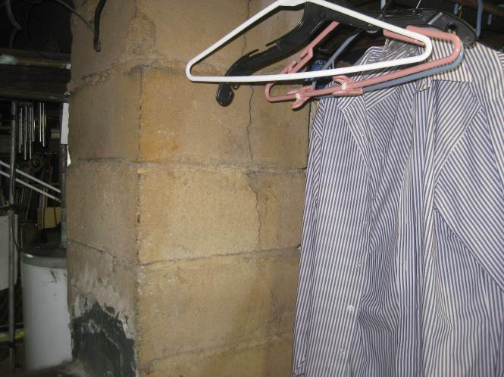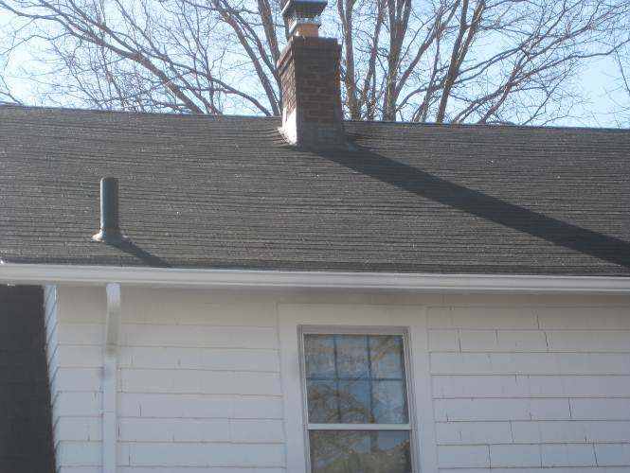
________________________________________________________________________________________________________________
CHIMNEY CAP None NOT VISIBLE
Concrete Masonry Metal Other
Crack Spalling Deterioration Corrosion Loose
Edge of cap looks worn. May need some repair. Have a chimney company check further.
________________________________________________________________________________________________________________
VISIBLE FLUE LINER None NOT VISIBLE
Brick Block Clay Concrete Metal Metal Insert Rain Cap
Deterioration Corrosion Loose Crack Spalling Improper Advise Cleaning / Sweeping
May need a liner.
Contact a qualified technician to inspect the interior flue liner prior to purchasing the home. Clean and maintain chimney flues to promote safe and efficient operation of heating appliances and fireplaces. This should be done annually or as prescribed by the chimney technician as obstructions can occur.
Chimney was to high and I could not see most of the flue pipe.
_______________________________________________________________________________________________________________

ATTIC

701 5th Ave., New Hyde Park, NY 11040 03/06/12 10:00 AM
_______________________________________________________________________________________________________________
LIMITATION: No Access Sealed Stored Items Looked In Entered Hatch
Pull Down Insulated
Adjust door to attic to operate better.
________________________________________________________________________________________________________________
STRUCTURE Truss Rafter DAMAGED—NO
Warped Stain Rot Sag Loose Split
2X4 rafters. Looked ok.
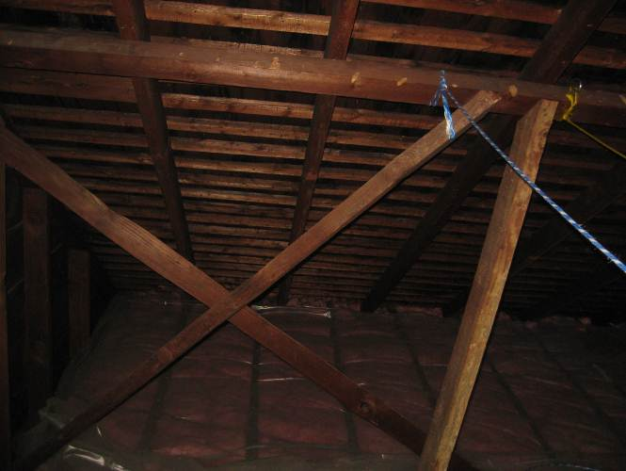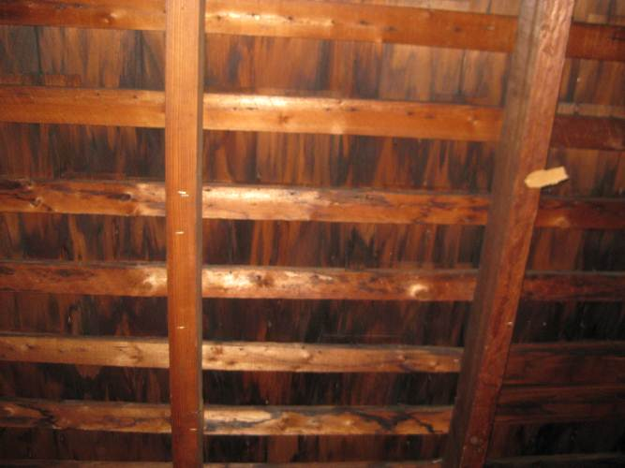
________________________________________________________________________________________________________________
SHEATHING Condensation DAMAGED—NO
Composite Thermal Board Plywood Board
Felt Paper Mildew Mold Sag Loose Stain Rot Delaminated
No sheathing on roof. Cedar shake shingles are acting as the sheathing.
________________________________________________________________________________________________________________
INSULATION Estimate Depth 6-8” FUNCTIONAL
Radiant Barrier Concealed Finished None Vapor Barrier Fiberglass Mineral Cellulose Foam
Wood Shavings Rigid Plastic Other Batt Blown Loose Sprayed Required
Remove plastic of top of insulation so it can breathe.
Because of age of house there may not be any insulation in the walls.
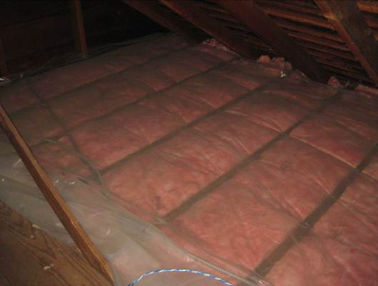
________________________________________________________________________________________________________________
VENTILATION None FUNCTIONAL
Soffit Gable End Turbine Mechanical Baffles Roof Ridge Blocked Required
________________________________________________________________________________________________________________
EXHAUST DUCT Concealed N/A

Not Insulated Into Attic Plastic Flex Metal
________________________________________________________________________________________________________________
ELECTRICAL Concealed DAMAGED—NO
Abandoned Knob & Tube Open Slice Frayed Open Junction Boxes Unsecured
ELECTRICAL SERVICE / PANEL

701 5th Ave., New Hyde Park, NY 11040 03/06/12 10:00 AM
________________________________________________________________________________________________________________
For all electrical deficiencies noted below consult a qualified Licensed electrician to review and provide repairs, improvements and upgrades as needed. These recommendations can impact safety in the home and should be addressed.
_______________________________________________________________________________________________________________
SERVICE ENTRANCE Underground Overhead No Conduit No Drip Loop
120-Volt 120/240 Volt Unsecured Frayed Service Line
ENTRANCE CABLE Concealed Aluminum Copper
MAIN DISCONNECT Switch / Cartridge Fuse Breaker
DISCONNECT RATING 100 Amps Have Electrician Evaluate
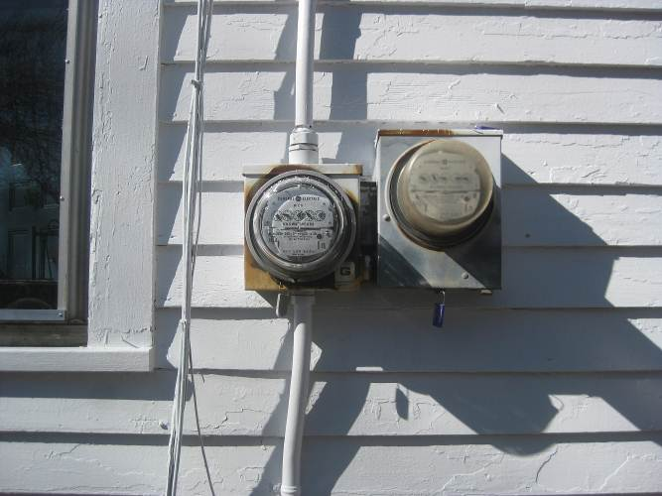
Two old meters.
________________________________________________________________________________________________________________
DISTRIBUTION PANEL Not Opened DAMAGED—NO
LOCATION BASEMENT Non Standard Installation
Obstructed Unsecured Corrosion Obsolete

PANEL RATING 100 Amps Room for Expansion

FUSE Breaker Glass / Screw Cartridge Time Delay GFCI / AFCI Breaker Blown / Broken Over-Fused
2 panels. Water was seen in the basement panel. Some corrosion was seen on some breakers. Have an electrician check further.
2nd panel on 1st floor looked ok.
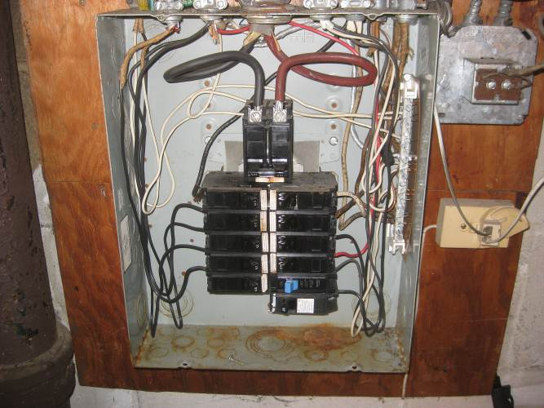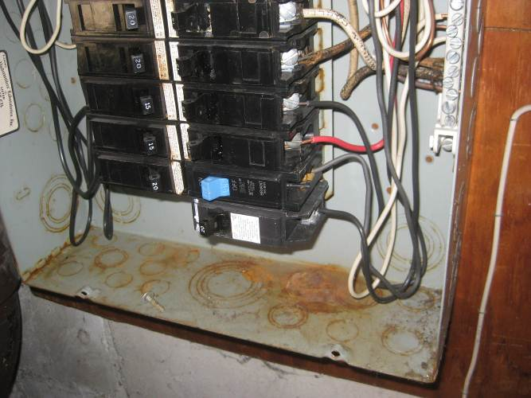
Basement Panel.
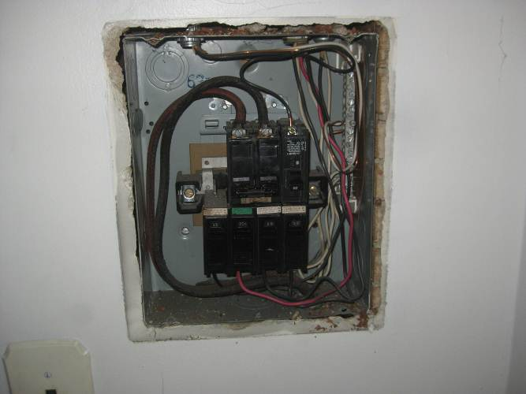
Panel for 2nd floor.
________________________________________________________________________________________________________________
CIRCUIT WIRE Improper DAMAGED—NO
Aluminum Copper Copper Clad Other
Non-Metallic Sheathed Armoured Cable Knob & Tube Double Tapping Spliced Corrosion Scorched

GROUNDING Concealed Ground Rod Water Main
Improper Connection / Installation Corrosion Unsecured
The integrity of the electrical system ground cannot be verified by a visual inspection.

BONDING Concealed Water Pipe Gas Pipe
Improper Connection / Installation Corrosion Unsercured
I recommend bonding the gas pipe to give it zero potential. Consult with an electrician.
_________________________________________________________________________________________________________________

BASEMENT / STRUCTURE

701 5th Ave., New Hyde Park, NY 11040 03/06/12 10:00 AM
_______________________________________________________________________________________________________________
LIMITATION Finished Clutter Obstruction Dry Weather / Drought Dry Ground
________________________________________________________________________________________________________________
FLOOR Crack Concrete Dirt DAMAGED—YES
Carpet Ceramic Vinyl Wood Laminate 9” Tile
Floor was uneven and heaved in some areas. Repairs will be needed to level floor.

Basement structure conditions were concealed by stored items along walls and floor. 80 to 90 % concealed.
________________________________________________________________________________________________________________
WALL Concrete Block Brick Stone PWF / Wood DAMAGED—NO
Mildew / Mold Moisture Stains Effervescence Crack Concealed
Water stains were seen on the walls. Water occasionally leaks in in heavy rain. I recommend having a waterproofing company check further. Some cracks in the block walls will need to be patched. Have a mason repair.
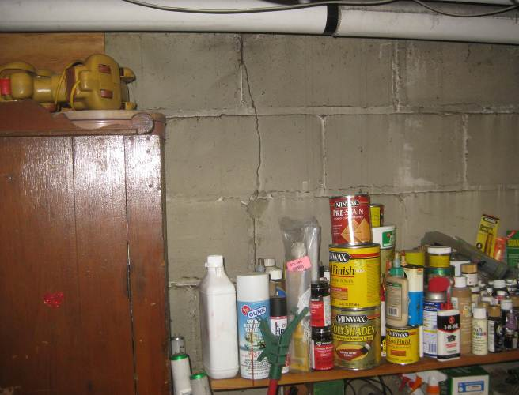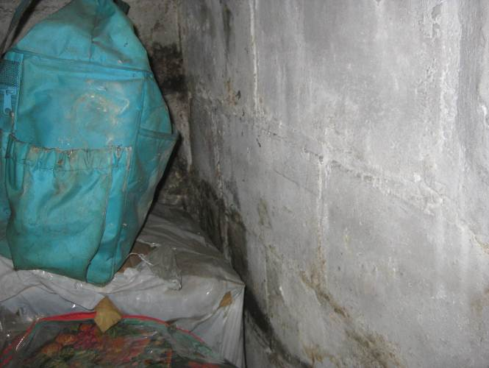
Repair crack. Water stains.
__________________________________________________________________________________________
CEILING Stain Unfinished DAMAGED—NO
Drywall Plaster Wood Fixed Tile Drop Down Tile Insulated Uninsulated
________________________________________________________________________________________________________________
WINDOW Binds Not Tested DAMAGED—YES
Single / Double Hung Casement Awning Sliding Fixed Bay / Bow
Thermal Aluminum Metal Vinyl / Vinyl Clad Wood
Damaged Mildew / Mold Stain / Rot Repaint Recaulk
Some rot was seen on basement windows. I recommend replacing.
_________________________________________________________________________________________
DOOR Binds Damaged OPERATIONAL—N/A
Pocket Hinged Wood Composite
_______________________________________________________________________________________________________________
LIGHTING Minimal Unsecured OPERATIONAL—YES
_______________________________________________________________________________________________________________
RECEPTACLE Damaged No Cover Unsecured OPERATIONAL—YES
Reverse Polarity Install GFCI No Ground Open Ground
_______________________________________________________________________________________________________________
CIRCUIT WIRE Concealed Unsecured Improper DAMAGED—NO
_______________________________________________________________________________________________________________
HEAT SOURCE None Thermostat Electric Air Register Convector Radiator Radiant
_______________________________________________________________________________________________________________
BASEMENT STAIRWAY Unsecured DAMAGED—NO
Carpet Vinyl Wood Worn Trip Hazard Low Headroom
_______________________________________________________________________________________________________________
RAILING Unsecured DAMAGED—NO
Metal Wood Incomplete None
Need a proper handrail for the stairs.
_______________________________________________________________________________________________________________
FLOOR JOIST Concealed DAMAGED—NO
Unsecured Split Notched Stain Rot Other

Joists looked ok. Some sagging seen.

_______________________________________________________________________________________________________________
BRIDGING Concealed None DAMAGED—NO
Continuous X-Metal X-Wood Solid Wood
_________________________________________________________________________________________
SILL PLATE Concealed DAMAGED—NO
Moisture Gasket Termite Shield Mildew / Mold Stain / Rot No Anchors
Sill plate looked ok in the main basement area.
Sill plate looked ok in the back crawlspace.
The sill plate was sagging and had some rot damage in the front crawlspace. It will need repair.
_______________________________________________________________________________________________________________
BEAM Unsecured Concealed DAMAGED—YES
Laminate Metal Wood Sag Notched / Bored Insufficient End Bearing
Main beam was cracked and sagging. I recommend replacing.
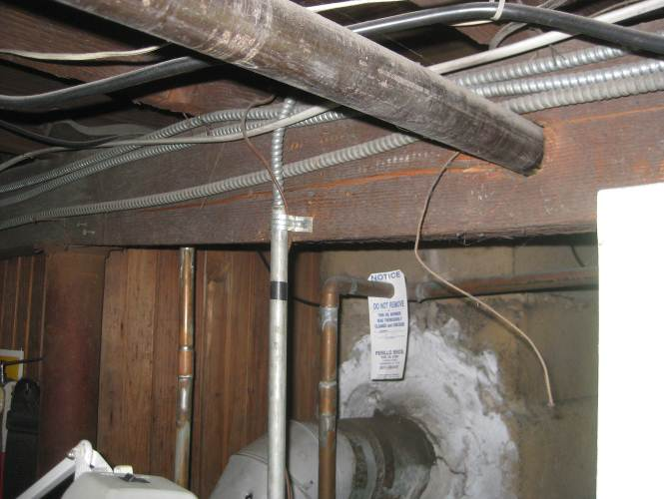 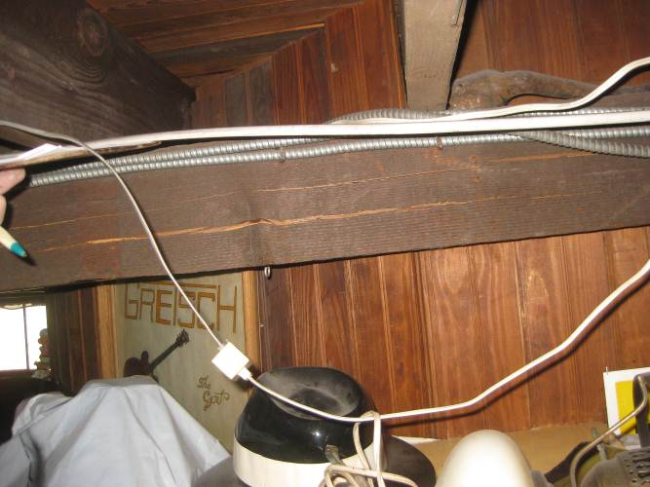 _______________________________________________________________________________________________________________
POST On Slab Unsecured Concealed DAMAGED—NO
Adjustable Brick Block Concrete Metal Wood
________________________________________________________________________________________________________________
BEARING WALL Concealed DAMAGED—NO
________________________________________________________________________________________________________________
COLD ROOM Improper Door N/A
Concrete Brick Block Stone Parged Earth Floor Mildew / Mold Stain / Damp Crack
________________________________________________________________________________________________________________
CRAWL SPACE No Access Limited Access DAMAGED—NO
Vapor Barrier Insulated Insulation Upside Down Entered Looked In
Crack Mildew / Mold Stain / Rot Damp Water Stains Sump Pump
Earth Floor Concrete Moisture Barrier Required
PIPES / DUCTS Unsecured Leak Insulated Uninsulated
VENTILATION Mechanical Blocked Required
Back crawlspace looked ok. Add more insulation.
Front crawlspace needs to be cleaned out and a moisture barrier put down on the earth floor.
Also front wall will need to be supported better.
I recommend insulating between the floor joists.
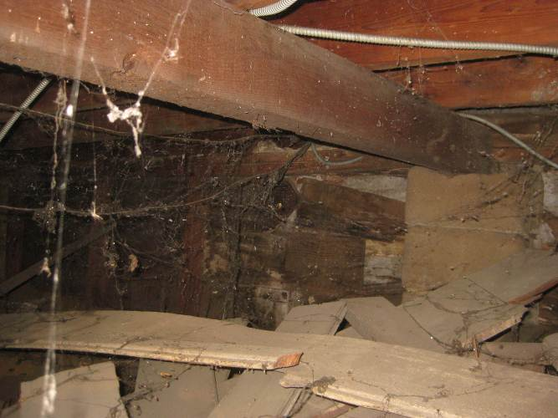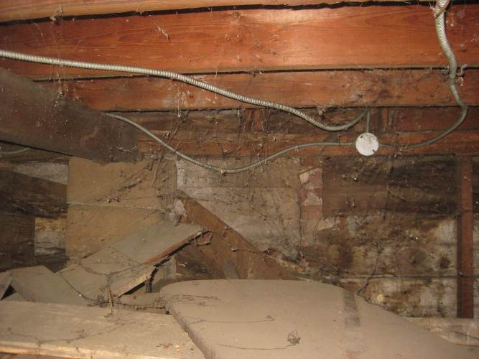
Front crawlspace. Beam is where floor sticks up in front room. Hard to see but the sill plate has no support and is sagging on either side of the beam. Added support is needed.
________________________________________________________________________________________________________________

HEATING/COOLING/VENTILATION

701 5th Ave., New Hyde Park, NY 11040 03/06/12 10:00 AM
_______________________________________________________________________________________________________________
DATA PLATE: Not Legible Incomplete Model IDEAL BOILER Btu Input N/A Est. Age 90 yrs
LIMITATIONS: Clean-Out Does Not Open Oil / Propane Tank Not Visible System Operating in Heat / AC
System Shut-Off / Inoperative Piping / Ducts Concealed Weather / Temperature
________________________________________________________________________________________________________________
SMOKE DETECTORS Basement 1st Floor 2nd Floor 3rd Floor Other None seen
CO DETECTORS Basement 1st Floor 2nd Floor 3rd Floor Other None seen

Provide NEW Carbon Monoxide sensors in bedroom areas and rooms with fuel burning appliances.
Recommend installation of NEW smoke detectors for safety of occupants.

________________________________________________________________________________________________________________
THERMOSTAT / HUMIDISTAT Unsecured OPERATIONAL—YES
LOCATION In living room. Programmable Standard

Replacing standard units with programmable thermostats will assist in reducing heating costs.
___________________________________________________________________________________________________
FUEL SOURCE Gas / Propane Oil Wood / Pellet Electric
HEAT TYPE Convertor Forced Air Radiator
BURNER TYPE Conventional Mid-Efficiency High-Efficiency
________________________________________________________________________________________________________________
HEATING SYSTEM Advise Service / Repair Contract OPERATIONAL—YES
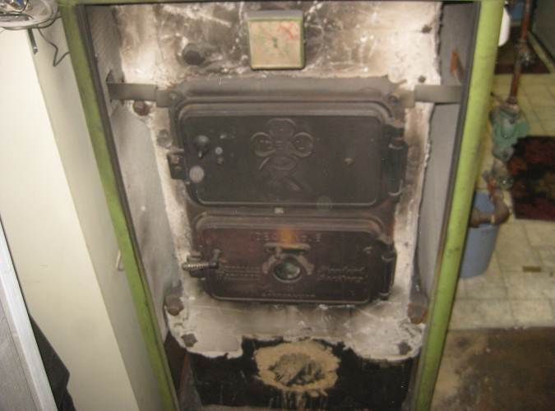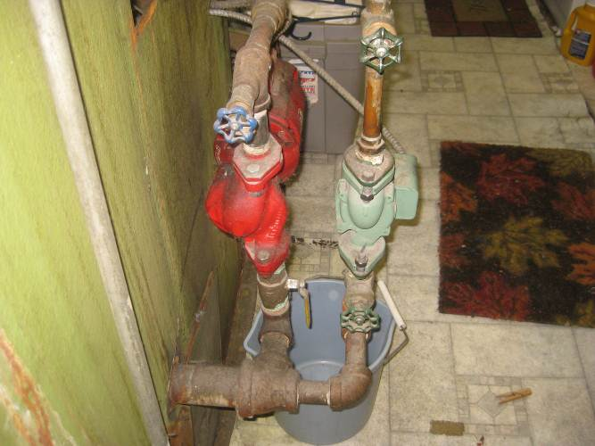
AIR REQUIREMENTS Internal External Inadequate
VENTING Flue Sidewall Metal Plastic
Improper Rises Unsecured Corrosion Soot
LIFE EXPECTANCY Typical Middle End Exceeded

This is an oil fired, cast iron boiler, 2 zone hot water heating system.
The boiler is very old and replacement should be considered.
Advise Annual Preventive maintenance agreement from a local contactor.
Unit is showing signs relative to age and wear and is functioning as intended.
_________________________________________________________________________________________________________________
HOT WATER (w) / STEAM (s) DAMAGED—NO
BOILER CASE (w) Deterioration Corrosion OK
CIRCULATING PUMP (w) Inoperative Corrosion OK
AQUASTAT (w) Missing Corrosion Unsecured
BACK FLOW PREVENTOR Missing Corrosion Leak
PRESSURE REDUCER (w) Missing Corrosion Leak
EXPANSION TANK Location
Drain Tank Open Closed Diaphragm
Waterlogged Unsecured Corrosion Leak
PIPING (w/s) Deterioration Corrosion Leak
PRESSURE RELIEF VALVE Missing Corrosion Leak
SITE GLASS (s) Missing Corrosion Low Water
LOW WATER CUTOFF (s) Missing Corrosion Leak
PRESSURE CONTROLLER (s) Missing Corrosion Leak
Some signs of a material that looks like asbestos seen on pipes. Have tested to be sure.
Budget for removal

________________________________________________________________________________________________________________
OIL BURNER BLOWER Not Checked OPERATIONAL—YES
BURN CHAMBER Deterioration Advise Adjustment Burn Through Corrosion Crack Soot
INSPECTION DOOR Missing Soot Sealed
BAROMETRIC DAMPER Missing Unbalanced Sealed
OIL TANK / PIPING Basement Outside Buried
No Filter Unsecured Corrosion Kink Leak
I recommend abandoning the buried oil tank.
________________________________________________________________________________________________________________

PLUMBING COMPONENTS

701 5th Ave., New Hyde Park, NY 11040 03/06/12 10:00 AM
_______________________________________________________________________________________________________________
LIMITATION Finished Basement Private / Water Shut Off Private System Cluttered Basement
________________________________________________________________________________________________________________
PUBLIC SUPPLY Concealed FUNCTIONAL
Lead Galvanized Plastic Copper
SHUT-OFF VALVE Location BASEMENT – front wall
Not Tested Corrosion Leak

Water flow was acceptable at time of inspection.
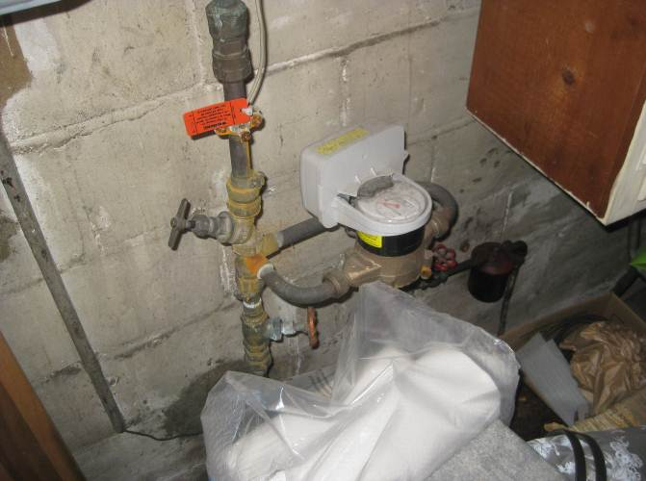
________________________________________________________________________________________________________________
HOSE BIBB Not Checked Water Supply Off N/A
Frost Free Anti-Siphon Shut Off Valve Recaulk Unsecured Corrosion Leak
________________________________________________________________________________________________________________
DISTRIBUTION PIPING Concealed DAMAGED—NO
Lead Galvanized Plastic Copper Dissimilar Metals Unsecured Corrosion Leak
Corrosion was seen on several pipes at the connections. Some corrosion seen on the shutoff valves handles. Possible leak on elbow. Have a plumber repair.
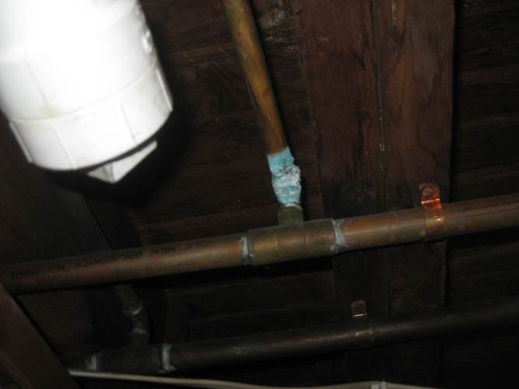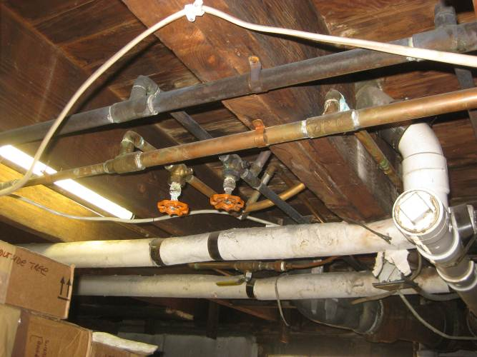
________________________________________________________________________________________________________________
WASTE DRAINAGE Concealed DAMAGED—NO
Galvanized / Steel Cast Iron Plastic Copper
Odor Unsecured Corrosion Leak Advise Cesspool Tank Checked / Pumped
Minor crack seen on the top of the cast iron waste pipe. This can be a future concern if the crack gets bigger. Have a plumber check further.
Galvanized steel water piping has not been used in homes since the late 1950’s early 1960's over time water passing through the pipes literally consumes the zinc once the zinc has worn away the exposed steel will rust from the inside out or close the diameter of the piping like a corroded artery reducing the water flow to the plumbing fixtures. There is no known health hazard associated with galvanized piping, certifying the condition of the piping is beyond the scope of this inspection.
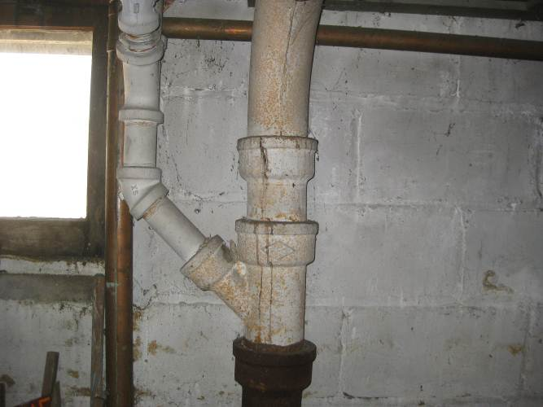
FLOOR DRAIN None Backed-Up No Water No Trap
________________________________________________________________________________________________________________
VENT STACK / PIPING Concealed DAMAGED—NO
Galvanized / Steel Cast Iron Plastic Copper
Undersized Unsecured Corrosion Leak
MAIN CLEANOUT Concealed N/A
Improper Plug LOCATION NONE
May need to install a house trap. Consult with a plumber.
_______________________________________________________________________________________________________________
HOT WATER TANK Hybrid Heating DAMAGED—NO
Power-Vented Own Rent Est. Capacity 32 Gas / Propane Oil Wood / Coal Electric
Dirty Rusty Odor Unsecured Corrosion Leak
LIFE EXPECTANCY Typical Middle End Exceeded
Unit is nearing end of normal life. Budget to replace in future.
FLUE SHUT-OFF Concealed Not Tested Location
RELIEF VALVE No Test Lever Corrosion Leak Other
DISCHARGE TUBE Undersized Discharge Missing
AGE: 9 Years
Unit appears in sound condition
________________________________________________________________________________________________________________
VENTING Flue Sidewall FUNCTIONAL
Improper Rise Unsecured Corrosion Soot
BURN CHAMBER Not Checked Needs Adjustment Looked ok.
________________________________________________________________________________________________________________
WASHER Make Kenmore OPERATIONAL—YES

DRYER Make Kenmore Replace old recalled flex gas pipe with safer new one.
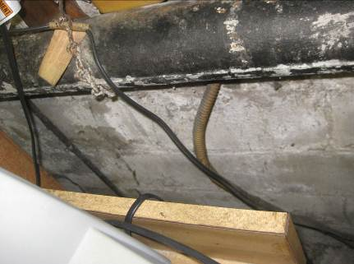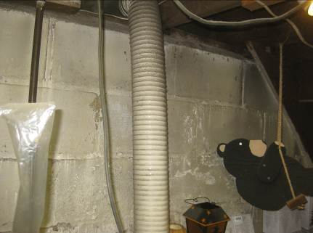

DRYER VENT Unsecured OPERATIONAL—YES
With Other Exhaust To Crawlspace To Attic To Exterior Plastic Duct
Replace plastic duct with metal for fire safety.

Clean exhaust vent periodically, depending on use, but at least every 2 years, or when installing your dryer in a new location. Disconnect vent from the dryer and clean one section at a time until you reach the exhaust hood.
To clean out lint, use the hose attachment on your vacuum, or a pole or wire with a feather duster or rag
attached. Be sure the flapper on the outside end of vent moves freely. When cleaning is complete, be sure to follow the Installation Instructions supplied with your dryer for final product check."
________________________________________________________________________________________________________________

TWO BATHROOMS

701 5th Ave., New Hyde Park, NY 11040 03/06/12 10:00 AM
_______________________________________________________________________________________________________________
LOCATIONS Basement 1st Floor 2nd Floor 3rd Floor Other
________________________________________________________________________________________________________________
WATER FLOW Normal Suspect Low
________________________________________________________________________________________________________________
FLOOR Worn Crack Stain DAMAGED—NO
Carpet Vinyl Wood Laminate Ceramic
________________________________________________________________________________________________________________
WALL Patched Unfinished DAMAGED—NO
Drywall / Plaster Brick / Block / Stone Wood Wallpaper Ceramic
________________________________________________________________________________________________________________
CEILING Patched Unfinished DAMAGED—NO
Drywall / Plaster Drop In Tile Fixed Tile Wood
________________________________________________________________________________________________________________
WINDOW Binds Damaged DAMAGED—NO
Single / Double Hung Casement Awning Sliding Fixed Bay / Bow
Thermo Aluminum Metal Vinyl Vinyl Clad Wood
Damaged Mildew / Mold Stain Rot Repaint
________________________________________________________________________________________________________________
DOOR Binds Damaged OPERATIONAL—YES
Pocket Bi-Fold Hinged Wood Composite
________________________________________________________________________________________________________________
LIGHTING None Unsecured OPERATIONAL—YES
________________________________________________________________________________________________________________
RECEPTACLE Damaged No Cover OPERATIONAL—YES
Reverse Polarity GFCI Receptacle No Ground Open Ground
________________________________________________________________________________________________________________
EXHAUST FAN Advise Installation OPERATIONAL—N/A
________________________________________________________________________________________________________________
SINK Worn Chipped Scratch DAMAGED—NO
_______________________________________________________________________________________________________________
FAUCET No Shut-Off DAMAGED—NO
_______________________________________________________________________________________________________________
TRAP / DRAIN Unsecured DAMAGED—NO
Improper Trap S-Trap Slow Drain Corrosion Leak Patched
_______________________________________________________________________________________________________________
VANITY Worn Unsecured DAMAGED—NO
Laminate Plywood Wood Metal
Old vanity
_______________________________________________________________________________________________________________
COUNTER Worn Unsecured N/A
Solid Surface Marble Granite Laminate Ceramic
Regrout Recaulk Mildew Stain Scratch
_______________________________________________________________________________________________________________
TOILET No Shut-Off DAMAGED—NO
Tank Loose Unsecured Crack Leak
First floor toilet does not flush well. Have a plumber check further. _______________________________________________________________________________________________________________
TUB / ENCLOSURE Unsecured DAMAGED—NO
Ceramic Cult./Marble Fiberglass Plastic
Regrout Recaulk Mildew Stain Crack Worn Stopper Not Working
Clean and recaulk both tub areas.
_______________________________________________________________________________________________________________
JETTED TUB Not Tested DAMAGED—NO
GFCI Protected Motor Access No Motor Access Corrosion Leak
_______________________________________________________________________________________________________________
FAUCET / SHOWER HEAD Not Tested DAMAGED—NO
Sticks Clogged Unsecured Corrosion Leak
Old faucets. Budget to replace.
________________________________________________________________________________________________________________
SHOWER / ENCLOSURE Unsecured N/A
Ceramic Cult./Marble Fiberglass Plastic
Regrout Recaulk Mildew Stain Crack Worn
FAUCET / SHOWER HEAD Not Tested N/A
Sticks Clogged Unsecured Corrosion Leak
________________________________________________________________________________________________________________
HEAT SOURCE None Thermostat Electric Air Register Convector / Radiator Radiant

TWO KITCHEN(S)

701 5th Ave., New Hyde Park, NY 11040 03/06/12 10:00 AM
_________________________________________________________________________________________________________________
LOCATIONS Basement 1st Floor 2nd Floor 3rd Floor Other
_________________________________________________________________________________________________________________
FLOOR Worn Crack Stain DAMAGED—NO
Carpet Vinyl Wood Laminate Ceramic
Floors are worn and uneven.
________________________________________________________________________________________________________________
WALL Patched Unfinished DAMAGED—NO
Drywall / Plaster Brick / Block / Stone Wood Wallpaper Ceramic
________________________________________________________________________________________________________________
CEILING Patched Unfinished DAMAGED—NO
Drywall / Plaster Drop In Tile Fixed Tile Wood
________________________________________________________________________________________________________________
WINDOW Binds Damaged DAMAGED—NO
Single / Double Hung Casement Awning Sliding Fixed Bay / Bow
Thermo Aluminum Metal Vinyl Vinyl Clad Wood
Damaged Mildew / Mold Stain Rot Repaint
________________________________________________________________________________________________________________
PATIO DOOR Binds Damaged N/A
Metal / Vinyl Wood Hinged Sliding ________________________________________________________________________________________________________________
LIGHTING None Unsecured OPERATIONAL—YES
CEILING FAN None Unsecured N/A
RECEPTACLE Damaged No Cover OPERATIONAL—YES
Reverse Polarity Install GFCI Receptacle No Ground Open Ground
Install GFCI receptacles for added safety.

SINK Worn Chipped Scratch DAMAGED—NO
_______________________________________________________________________________________________________________
FAUCET No Shut-Off DAMAGED—NO
_______________________________________________________________________________________________________________
TRAP / DRAIN Unsecured DAMAGED—NO
Improper Trap S-Trap Slow Drain Corrosion Leak Patched
________________________________________________________________________________________________________________
COUNTER Unsecured DAMAGED—NO
Ceramic Marble / Granite Laminate Solid Surface
Regrout / Recaulk Mildew / Stain Scratch Worn
Second floor countertop looked ok. First floor was worn.
CABINETS Unsecured Worn DAMAGED—NO
Plywood Wood Laminate Metal
Missing / Loose Hardware Mildew / Stain Scratch Other
Cabinets were old and worn. New sink base on second floor looked ok.
_________________________________________________________________________________________________________________
RANGE HOOD Cooktop Exhaust DAMAGED—NO
Corrosion No Exhaust No Light Noisy
Add a range hood over second floor stove.
EXHAUST VENT Unsecured Ductless Concealed OPERATIONAL—YES
With Other Exhaust To Attic Improper To Exterior
FILTER None Unsecured Damaged Greasy
_________________________________________________________________________________________________________________
MAJOR APPLIANCES (Built In)
DISHWASHER OPERATIONAL—N/A
STOVE / OVEN / RANGE OPERATIONAL—YES
REFRIGERATOR OPERATIONAL—YES
Ice maker does not work and leaks water.
MICROWAVE N/A
Tested On / Off Did Not Check All Functions / Full Cycle
_________________________________________________________________________________________________________________
HEAT SOURCE None Thermostat Electric Air Register Convector / Radiator Radiant

HOUSE ROOMS
701 5th Ave., New Hyde Park, NY 11040 03/06/12 10:00 AM
________________________________________________________________________________________________________________
INTERIOR GENERAL COMMENTS
The interior consisting of the bedrooms, living and dining rooms, and other common spaces were similar in make up and materials and all comments will be listed in this section. Specific conditions and remarks will identify the individual room in question (ie; Bedroom, Living Room ) and noted conditions should such exist at the time of the inspection.
The comments are intended to give an overview and highlight areas that may require maintenance, improvements, repairs or updating:
_________________________________________________________________________________________________________________
FLOOR Worn Crack Stain DAMAGED—NO
Carpet Vinyl Wood Laminate Ceramic
Floors throughout the house were sagging and uneven. Added support in the basement will be needed.
________________________________________________________________________________________________________________
WALL Patched Unfinished DAMAGED—NO
Drywall / Plaster Brick / Block / Stone Wood Wallpaper Ceramic
Some cracks were seen in the plaster walls.
________________________________________________________________________________________________________________
CEILING Patched Unfinished DAMAGED—NO
Drywall / Plaster Drop In Tile Fixed Tile Wood
Some old water stains were seen.
________________________________________________________________________________________________________________
STAIRWAY Unsecured DAMAGED—NO
Carpet Vinyl Wood Worn Trip Hazard
RAILING Unsecured DAMAGED—NO
Metal Wood Incomplete None
_______________________________________________________________________________________________________________

WINDOW Binds Damaged DAMAGED—YES
Single / Double Hung Casement Awning Sliding Fixed Bay / Bow
Thermo Aluminum Metal Vinyl Vinyl Clad Wood
Damaged Mildew / Mold Stain Rot Repaint
Old wood windows open ok where tested. Some panes were cracked. Some sashes were coming apart. They will need some maintenance or repair to get them into good condition. Add weep holes in the storm windows to remove excess water. Vinyl casement windows were ok.
________________________________________________________________________________________________________________
DOORS Binds Damaged DAMAGED—NO
Pocket Bi-Fold Hinged Wood Composite
Adjust some doors to stop binding.
________________________________________________________________________________________________________________
PATIO DOORS Binds Damaged DAMAGED—NO
Metal / Vinyl Wood Hinged Sliding
Old wood doors. Adjustments are needed for doors to close better. Could use better weather stripping.
________________________________________________________________________________________________________________
CLOSET DOORS Binds Damaged DAMAGED—NO
Metal / Vinyl Wood Hinged Sliding
________________________________________________________________________________________________________________
LIGHTING None Unsecured DAMAGED—NO
CEILING FAN None Unsecured DAMAGED—NO
RECEPTACLE Damaged No Cover DAMAGED—NO
_________________________________________________________________________________________________________________
FRONT DOOR Damaged DAMAGED—NO
Binds Metal Clad Wood Dead Bolt
Front door rubs on the floor because of settlement of the front exterior wall and the floor having a beam under it that did not settle.
_________________________________________________________________________________________________________________
HEAT SOURCE None Thermostat Electric Air Register Convector / Radiator Radiant

Additional Comments
701 5th Ave., New Hyde Park, NY 11040 03/06/12 10:00 AM
____________________________________________________________________________________

General Comments

This inspection is performed to the Standards of Practice of New York State and is visual in nature, and does not address building code compliance issues which are the purview of municipal building inspectors.

Limitations

Chimney - The interior of chimneys and their flue liners are not visible on our visual inspection. You are advised to obtain the services of a qualified chimney sweeper or other qualified personnel to perform a complete inspection and tune up of your heating appliances prior to use.

Occupied Home – The home is occupied by the current owner with their personal belongings and furniture which limits some areas of inspection.

Circuit Sizing - The Inspector is required to address the compatibility of conductors and overcurrent devices. In some instances, general trade procedures include over-sizing overcurrent devices to guard against nuisance (e.g. air conditioning units, dryers). The Inspector is not required to evaluate such general trade procedures, but to inform you of incompatibility.

Cluttered Conditions - The home is in a cluttered condition with excess furniture, personal belongings, storage boxes, etc. throughout the home. This limits the inspection and could conceal defects or damage that could otherwise be visible.
An opportunity to view the property prior to the closing with all excess items removed at the final walkthrough is customary and all areas should be checked at this time.

Vintage Homes - (homes built prior to 1950) - Character homes have inherent defects because they were built without the benefit of the standardized Building Codes. You must keep in mind that the defects noted throughout this report are typical of such dwellings because of normal wear and tear throughout the years. Often, maintenance repairs are ongoing and done based on your budget. If you tried to repair or improve all at once, costs could become high to the point where it is not practical or affordable to you at this time. Repairs or improvements which you would like to repair in the immediate future or have been advised to do, should be quoted prior to purchase by qualified contractors for costs and methods of repair.

701 5th Ave., New Hyde Park, NY 11040 03/06/12 10:00 AM
____________________________________________________________________________________________________

Supplementary Comments

Not all receptacles/outlets tested due to limited accessibility (i.e. furniture, clutter and/or obstructions).

Not all windows or doors may have been checked due to obstructions (i.e. blinds, curtains and/or furniture).

Finished, insulated or cluttered basement prevents complete assessment of foundation, plumbing and electrical wiring.

It is very important that water & runoff drain away from foundations to minimize chance of water leakage into the basement, as cracks in foundation walls are common. Make sure the ground, patios and walkways slope away from the house for the first six feet.

Seal, caulk, repoint and/or repair cracks / gaps around the house (i.e. windows, sills, bricks & siding).

Wooden siding, windows, doors, decks, fences and/or sheds will require regular upkeep. Keep wood off the ground!

It is important that water from eve troughs drains well away from house - at least 6 feet away from wall. Also it is usually better to reposition downspouts to drain water above ground and away from house, then cap drains.

Make sure that eaves troughs remain fastened securely, gutters are kept clean seasonally from leaves & debris and leaks are sealed. Also, ensure that tree branches are not rubbing against eve troughs and roof.

Ensure roof flashing remains fastened, lays flat and gaps / cracks are caulked & sealed promptly to prevent leaks.

Monitor the roof and attic on a seasonal basis for leaks and (wind) damage. Repair as soon as possible.

Monitor siding and/or shingle exterior regularly for looseness, (wind) damage and repair and/or fasten as necessary.

Parging, stucco, brick and stone facing can crack, loosen and/or spall with age - monitor and repair as necessary.

Recommend installing & testing regularly Carbon Monoxide Detectors (locate in bedroom area + rooms with fireplace) and new Smoke sensors (mandatory every floor). Propane & Natural Gas sensors are also available in stores.

Older stone, brick & block foundations are porous. There could be dampness or leakage at certain times of the year.

Ensure that any cracks / gaps in bathroom or kitchen ceramic tiles are grouted, caulked and sealed to prevent leaks.

Some ceilings and walls may require nail holes, nail pops, dimples and/or cracks to be patched before painting.

Patched, stained, loose and/or uneven drywall / plaster noted - monitor and/or improve.

Some windows or doors require maintenance, upkeep (i.e. painting, weather stripping, caulking) and/or adjusting.

Some windows, doors screens and/or hardware are dated, older, missing or damaged - upgrade, repair or replace

Keep humidity low to prevent condensation, stains, mildew forming on windows & walls (<25% = -20 C; <40% = 0 C)

Consider refinishing wooden floors prior to moving in (Approx. $1.50 / sq. foor).

Some floors and/or carpets show significant wear and tear - improve as required.

Squeaking, uneven and/or sagging floors noted - monitor, improve as necessary.

Skylights frequently have condensation problems and/or can leak - monitor regularly

Cold room / cantinas frequently become damp and/or occasionally leak.

Ceramic floor tiles, especially larger ones, can crack unexpectantly or become loose - repair as required.

MAJOR COMMENTS - REPORT COMMENTARY

701 5th Ave., New Hyde Park, NY 11040 03/06/12 10:00 AM

Main areas of concern were:

Chimney will need repair.
Some regrading is needed.
Old wood windows will need repair or replacement.
Front exterior wall of the house will need better support.
Siding will need some repair.
Water problems in the basement will need correcting.
Old electric panels should be upgraded.
Need to keep water out of basement electric panel.
Budget to replace old boiler.
Budget to abandon buried oil tank.
Budget to remove asbestos on heating pipes if it is asbestos.
Old water heater. Budget to replace.
Have a plumber fix corrosion and leaks in water pipes.
Check crack in main waste pipe.
Replace cracked main beam.
Replace brass gas flex pipe for dryer.
Remove plastic dryer duct and install metal duct.
Sagging floors throughout the house will need better support.
Upgrade first floor Kitchen.
Upgrade bathrooms.

